ODOO SETUP INFORMATION
This group has 4 different company:
- MACROSS MDA SA DE CV
- SENHAI INTERNATIONAL S DE RL DE CV
- VERRA GLASS SA DE CV
- A LA CAJA SA DE CV (new company not yet setup in odoo at this moment)

MACROSS MDA SA DE CV:
- Is an importer of float glass, mirror and disposable food and drinks container boxes.
- MACROSS import and sells mainly glass, mirror to SENHAI INTERNATIONAL and also sells some containers to VERRA GLASS.
- Currently MACROSS import disposable food and drinks container box and sells to SENHAI INTERNATIONAL because A LA CAJA is not setup yet.
- After setting up A LA CAJA in odoo, MACROSS will sell directly to A LA CAJA and will not sell to SENHAI INTERNATIONAL anymore.

PURCHASE:
- MACROSS buys imported glass and disposable box from foreign companies so they do not generate local Mexican sales tax (16%).
- MACROSS is in charge of dispatching containers and pay for all local import tax.
- MACROSS is in charge of logistic and deliver containers to SENHAI INTERNATIONAL warehouse.
- MACROSS do not have physical warehouse. Only have virtual warehouse for sales purpose.
- Products bought from foreign companies do not have product code or sku.
- MACROSS sometimes rebuys glass and mirror from SENHAI to sell to its local client, purchase order has product code and sku.
- Glass and mirrors comes in packages example 10 package per container.
- Disposable comes in boxes example 1500 boxes per container.
- Want to calculate what is glass cost per package by inputting all import related expense invoice into odoo.
- Macross buys import products and also local products.
- Current process is procurement area upload purchase order and all import documents sent by vendors and assign task to import area – import area upload import declaration such as import document and assign task to accounting area– accounting calculate cost of glass by package and by m2 in a separate excel file mark as completed task – inventory input glass into inventory with the cost provided by accounting.
- The cost provided by accounting is the “precost” because final expense invoice will be provided by third parties usually 2-3 weeks after containers are desconsolidated.
- The final cost of the glass and disposable products how to upload real cost? Will it affect precost and real cost?
- How to keep track of this cost and generate report how much the real final cost?

SALES:
- MACROSS has one main client SENHAI and other small local clients for glass & mirror products.
- Currently First process is sell all glass, mirror and disposable products to SENHAI. Because MACROSS don’t have a physical warehouse.
- If other local clients buys glass & mirror from MACROSS then SENHAI will resell the glass to MACROSS by generating sales invoice to MACROSS with product code and sku and including local sales tax 16%.
- After receiving sales invoice from SENHAI and create purchase order and transfer product to MACROSS virtual inventory with the same product code and sku, MACROSS will generate sales invoice to local clients.
- In the end there is no more products left in inventory, this process of buying and selling happens the same moment.
- Want to see report of packages sold daily, monthly, yearly, by clients, by zone, by sales agent by type of products.
- Sells glass by packages.
- Uses glass price list and additional discount for each clients. Example price list 1 discount 32% for senhai. Want to integrate by setting up discount assigned to each client don’t want to add the discount manually in each invoice, odoo should generate discount at the end of the sales invoice automatically.

PURCHASE AND SALES PROCESS DIAGRAM:

ACCOUNTING:
- Want to see all accounting related information between purchase and sales reflected in odoo.
- Invoicing accounts receivable and payable.
- Payment registration.
- Bank reconciliation.
- General ledger.
- Financial report.
- Tax management and local tax configuration.
- Asset management
- Accounts Receivable & Payable Tracking
- Want to integrate company expense such as import expense, operation expense, administrative expense, glass cost, inventory cost..etc
- Automation:
  - Sales → automatically creates invoices
  - Purchases → generates vendor bills
  - Inventory → impacts accounting valuation
  - Payroll → records salary expenses
- • Electronic invoicing setup (CFDI)
- How to show expense approvals in accounting and can generate invoice and payment automatically? Show internal folio to track and trace approvals.

INVENTORY:
- Reflect cost of the glass by package
- Weight of the glass by package
- Inventory by package example below.
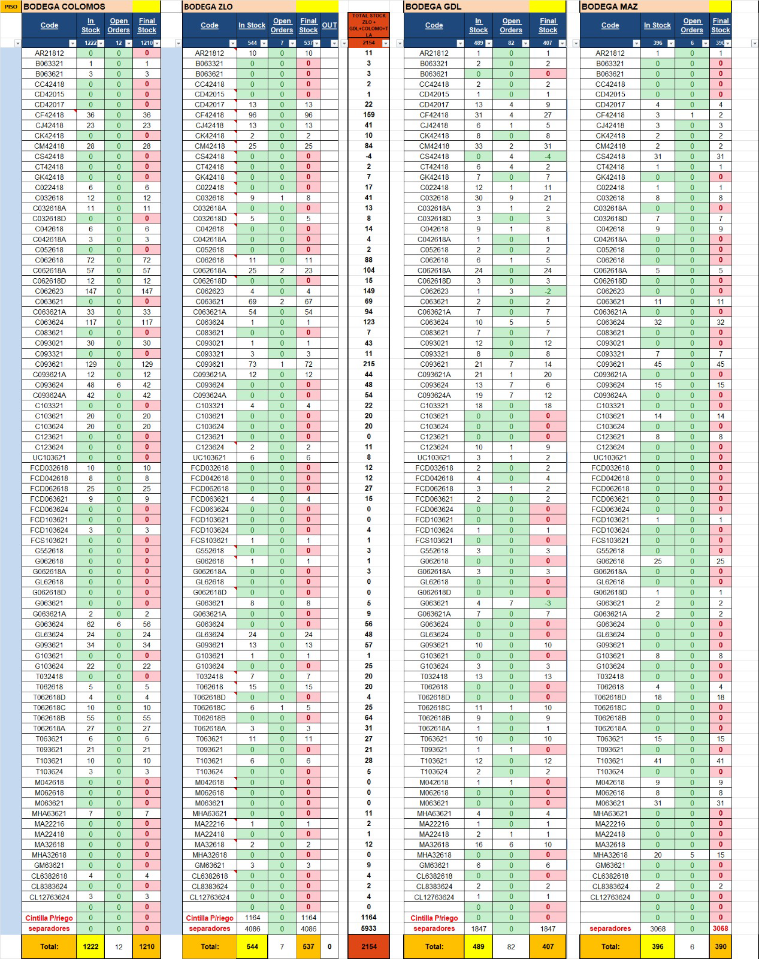

SENHAI INTERNATIONAL S DE RL DE CV:
- SENHAI Buys glass, mirror and disposable products from Macross MDA and sells to local clients.
- SENHAI also resells glass and mirror to MACROSS
- Has 3 different warehouse location: Fondeport, Colomos, Sauces

PURCHASE:
- Buys from MACROSS and sometimes other local vendors.
- SENHAI generate its own product code and sku.
- Glass and mirror product code are made up by a formula:
  - CLEAR 6MM 3.66 X 2.14 = C063621 product code
  - CLEAR = COLOR OF THE GLASS
  - 6MM = THICKNESS OF THE GLASS
  - 3.66 = LENGTH
  - 2.14 = HEIGHT
  - C063621-20 = 20 means how many sheets per package.
  - Same product code can have different amount of sheets per package. Example : C063621-22 , C063621-18, C063621-23
- Uses lots and serie to track product quality. Is it necessary?
- How to trace which purchase order it is and how much inventory left in this purchase order?
- How to trace purchase order if in a sales operation the glass has defect?

SALES:
- Sends glass/mirror price list by square meter to clients.
  - Example C06 price is $150 per m2, so 3.66 x 2.14 x 20sheets x $150 = $23,497.20 price per package
  - Want to be able to convert package to square meter to see what is price by square meter. 3.66 x 2.14 x 20 = 156.648 m2 // 23,497.20 /156.648 = $150 per m2.
  - Want to show sales order in package but with option to do conversion package to m2 to check if price is correct.
- All quoted price does not include discount or sales tax. All clients have discount (35%,34%,33%..etc) and need to add 16% sales tax.
- Discount is added apart but only applies to glass.
- Prefer to show price list in quote and hide discount, if possible.
- All price is fob price, does not include shipping. If clients want delivery shipping is added apart. Shipping cost does not have discount but do have sales tax.
- In sales invoice want to calculate (glass price list – glass discount + shipping cost + sales tax = final total to pay)
- Currently making sales order do not need to select lots/serie but making sales invoice need to show glass lots/serie. Is lots/serie necessary for tracking? Is there better alternative?
- Another extra discount is added when glass package has defect or missing sheets. Example C063621-20 one sheet is broken so we quote price of 20 sheets but apply discount to take out 1 sheet.
- Extra discount is also applied when there is a general promotion or offer. But this promotion or offer is only for certain glass not for the whole invoice.
- We also use credit note for future invoice or for refund.
- Sales invoice only generated during loading of the product. (products delivered)
- Show Sales invoice format simplified.
- Need sales electronic invoice
- Need payment electronic receipt
- Want to implement scanner to automatically select the product and sku into invoice.
- When delivery clients need to sign products received in delivery order, keep one copy for clients and one original for us

INVENTORY:

1. Stock Management
- Real-time tracking of inventory levels
- View available, reserved, and incoming stock
- Manage stock by product, location, or warehouse
- Show package weight

2. Multi-Warehouse & Locations
- Manage multiple warehouses
- Create internal locations (e.g., shelves, zones, bins)
- Transfer products between locations or warehouses

3. Inventory Movements
- Track all product movements:
  - Receipts (incoming goods)
  - Deliveries (outgoing goods)
  - Internal transfers
- Full traceability of who moved what and when

4. Barcode & Automation
- Use barcode scanning for faster operations
- Automate picking, packing, and shipping processes
- Reduce manual errors in warehouse operations

5. Lot & Serial Number Tracking??
- Track products by:
  - Lot (batch)
  - Serial numbers (unique items)
- Essential for quality control and traceability

6. Inventory Valuation
- Track inventory value in real time
- Supports costing methods:
  - FIFO (First In First Out)
  - Average Cost
- Automatically creates accounting entries (if integrated with Accounting)

7. Cycle Counts & Inventory Adjustments
- Perform physical inventory counts
- Adjust stock levels to match real inventory
- Schedule cycle counts for better control
- Want to create odoo id for operation in manufacture app, operation leader can access odoo only to scan bar code and generate code or check product location. This user id is only for operation function, check where products are located and scan product to receive and deliver.
ACCOUNTING:
- Want to see all accounting related information between purchase and sales reflected in odoo.
- Invoicing accounts receivable and payable.
- Payment registration.
- Bank reconciliation.
- General ledger.
- Financial report.
- Tax management and local tax configuration.
- Asset management
- Accounts Receivable & Payable Tracking
- Want to integrate company expense such as import expense, operation expense, administrative expense, glass cost, inventory cost..etc
- Automation:
  - Sales → automatically creates invoices
  - Purchases → generates vendor bills
  - Inventory → impacts accounting valuation
  - Payroll → records salary expenses
- • Electronic invoicing setup (CFDI)

HUMAN RESOURCE: for all employee even ones that don’t have odoo user id.

1. Employee Management
- Centralized employee database
- Store:
  - Personal info
  - Job position
  - Department
  - Contracts
- Track employee history and documents

2. Recruitment
- Create job positions and publish vacancies
- Track applicants through stages (pipeline)
- Schedule interviews
- Evaluate candidates

3. Time Off (Leave Management)
- Manage vacation, sick leave, permissions
- Employees can request leave
- Managers approve/reject
- Automatic tracking of balances

4. Attendance
- Track employee check-in / check-out
- Integrate with biometric or kiosk systems
- Monitor working hours and punctuality

5. Payroll
- Generate payslips
- Manage salaries, bonuses, deductions
- Handle taxes and social security (with proper localization)

6. Employee Contracts
- Define salary structure
- Set working schedules
- Manage contract start/end dates

7. Expenses
- Employees submit expense reports
- Approval workflow
- Reimbursement tracking
- Integration with accounting

8. Appraisals (Performance Evaluation)
- Schedule performance reviews
- Set goals and feedback
- Track employee development
- Make survey so other employees can evaluate supervisors or colleagues

9. Fleet Management: has 10 vehicles that need management.
- Manage company vehicles assigned to employees
- Track usage, costs, maintenance

10. Documents & Compliance
- Store contracts, IDs, certifications
- Ensure compliance with internal policies
- Track expirations (e.g., licenses)
- Have all documents like purchase or expense document in odoo server
- How to access and look for purchase order files?
APPROVALS:
- Currently general director signs all expense bills before they are process to accounting area. Sign by pdf format electronic signature
- Want to implement this process into odoo.
- Type of expense: mostly company related or employees travel expenses
- Want to show approvals expense in accounting and able to track them by internal folios.
VERRA GLASS
- Import only glass and mirror products and also sells to local clients.
- Has one warehouse
- Has same process like MACROSS in purchase and same process like SENHAI in sales.
- Is a combination of MACROSS and SENHAI
- Same process for accounting, inventory, human resource, approvals,

A LA CAJA
- Will import and sell to local clients
- Same process in purchase like MACROSS, import from foreign company.
- Need to generate own product code and sku
- Inventory by boxes with weight, show by boxes
- Sale price shown in boxes and conversion to pieces. Example 1 box contains 300 pieces
- Purchase, Accounting, human resource same as SENHAI

